Unit 9 – Lesson 3. Review of Basic Statistics and N-gram Models

Aim: What is N-Gram?

Objectives: After the lesson, students should be able to:
- Obtain understanding of N-gram

References:
- Stanford University, N-Grams and SLP
https://web.stanford.edu/class/cs124/lec/languagemodeling.pdf

CLASS PROCEDURE:
Do Now:
- What is the definition of mean, median and mode? Find the mean, median and mode in the sample data set.

13, 18, 13, 14, 13, 16, 14, 21, 13

Finding the mean ______________________

Finding the median _____________________

Finding the mode _______________________

- What is a standard deviation?

Class Discussion / Presentation – Review of Statistic Basics:

- Mean, median and mode.

- Mean – average

- Median – the middle value in the list of numbers

- Mode – the value occurs most often

- Standard deviation and variance

- The Standard Deviation is a measure of how spread out numbers are. It is the square root of the Variance, and the Variance is the average of the squared differences from the Mean.

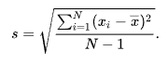

Pair – sharing Activity #1:

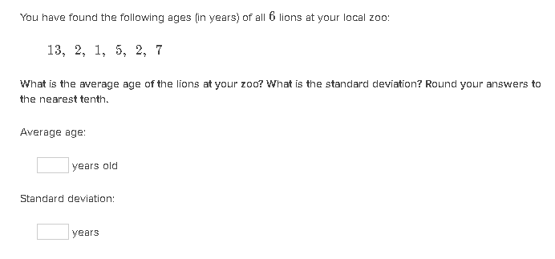

Pair – sharing Activity #2: Given the two diagrams below, which diagram has more spread out numbers?
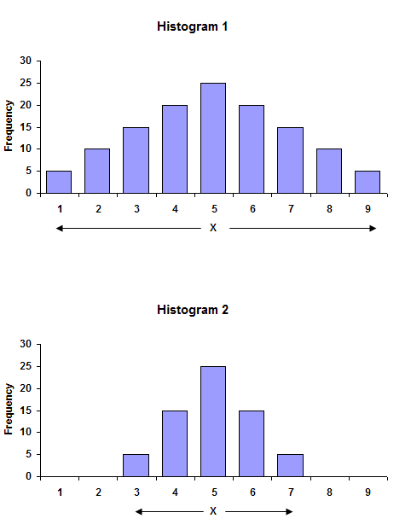

Class Discussion / Presentation:
Say we want to use several corpuses for our N-gram. When we collect data for our N-gram model, how do we apply mean, median, mode and standard deviation?

Pair – sharing Practice:

To fully understand the Ngram NLP model, for our next project we will use R to build a word predictor with Ngram. You can explore the sample work build by someone else here https://arttu.shinyapps.io/word_predictor/

Use https://campus.datacamp.com/courses/free-introduction-to-r/chapter-1-intro-to-basics-1?ex=1 to get familiar with the syntax of R.

If you are already familiar with R, read the PPT provided by this lesson and start to build the project.

Due: April 9th. Presentation in class.

